Required Capstone Checkpoint 4.1: Advanced Retrieval Implementation

Directions

Download this worksheet and save a copy to your device before you begin working. Use this worksheet to plan, organize, and complete your submission for Required Capstone Checkpoint 4.1. Type your responses directly into the document, save your completed work, and upload the finished file when you are ready to submit.
Completion Checklist
☐ Identification of a meaningful retrieval failure or limitation supported by evaluation evidence
☐ Analysis of the likely cause of the retrieval failure
☐ Selection and justification of an advanced retrieval strategy
☐ Evidence of implementation of the updated retrieval architecture
☐ Evaluation results comparing the updated system against the baseline system
☐ Reflection on the effectiveness of the architectural changes and any remaining limitations

Step 1. Retrieval Failure Identification
Identify a meaningful retrieval limitation in your current retrieval system.
- Describe the failure or limitation.
- Explain how the limitation affects retrieval performance.
- Reference evaluation evidence, test results, queries, or outputs that demonstrate the issue.
Retrieval failure or limitation
The dominant failures in the baseline retrieval system are very poor recall and precision when:
(1) the retriever must find specific details buried in very long documents
(2) the retriever is tasked with a query involving multiple entities
(3) the retriever is tasked with a complex query involving an unnamed entity

Evidence supporting the identified limitation
The following results from testing the baseline retrieval system using the test suite for 4.1 (Capstone\Checkpoint 4.1\mini-4.1-test-suite.json), which are reported in Capstone\Checkpoint 4.1\evaluation_results\evaluation_baseline_20260921_161030.json, illustrate these failures:
- G16 “Was Charles II born before his mother’s reign began?”
The following screenshots show that the system was unable to answer this question and that all recall and precision metrics are 0.
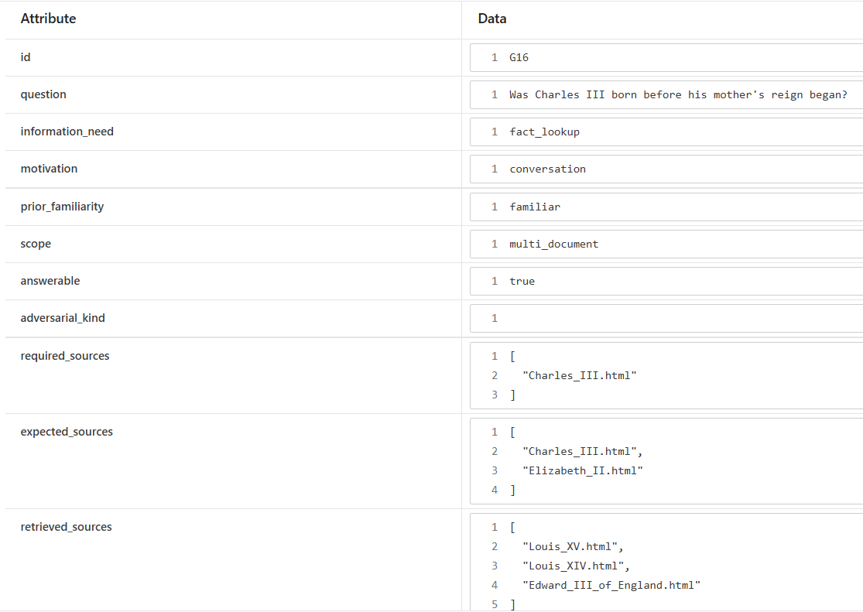
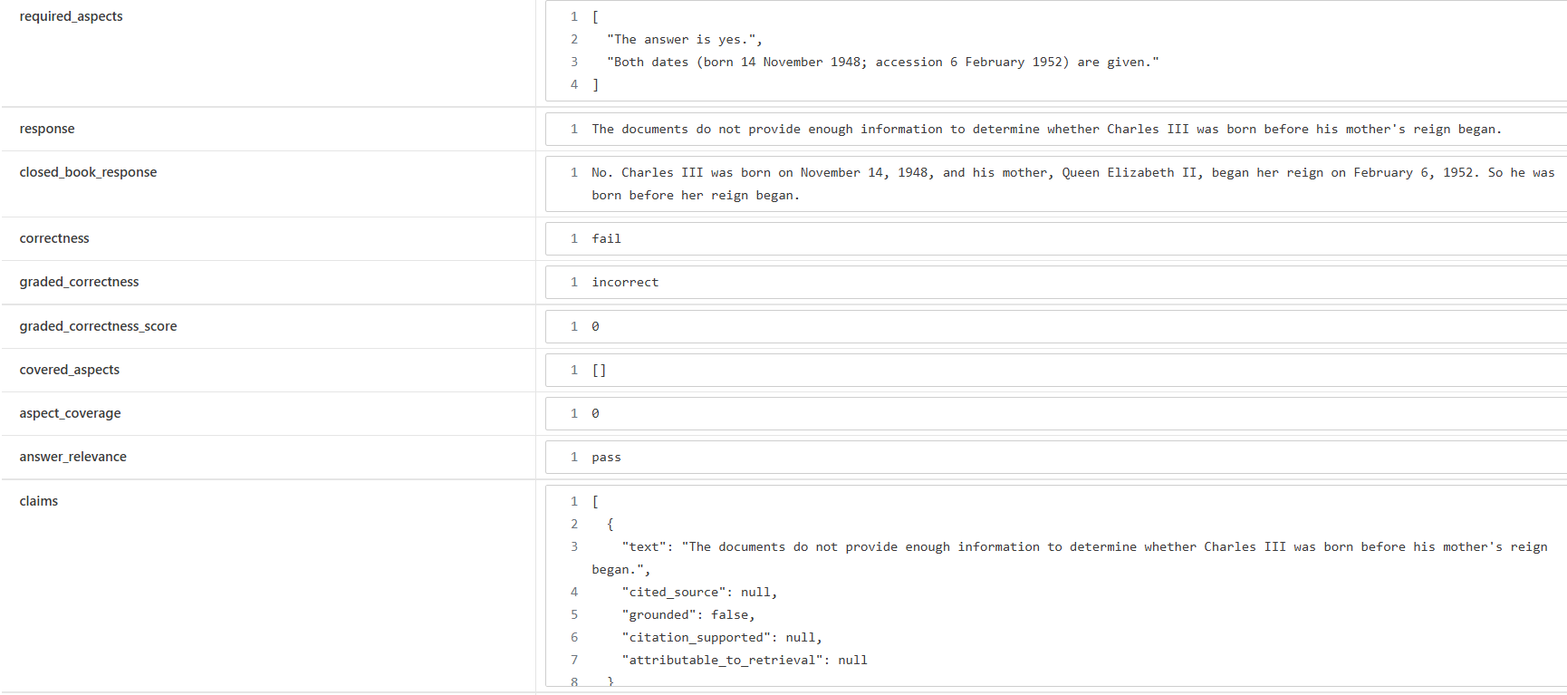

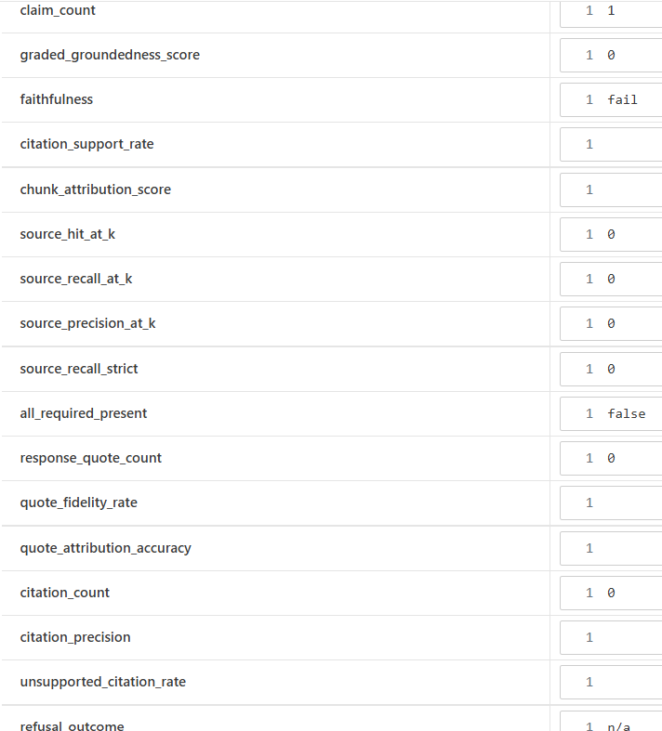
- Q003 “Compare the Academy Awards ceremonies held a decade apart: who hosted the 85th and 95th ceremonies, and which film won Best Picture at each?”
In this instance, the system was able to provide a partial answer despite once again scoring 0 on the recall and precision metrics. 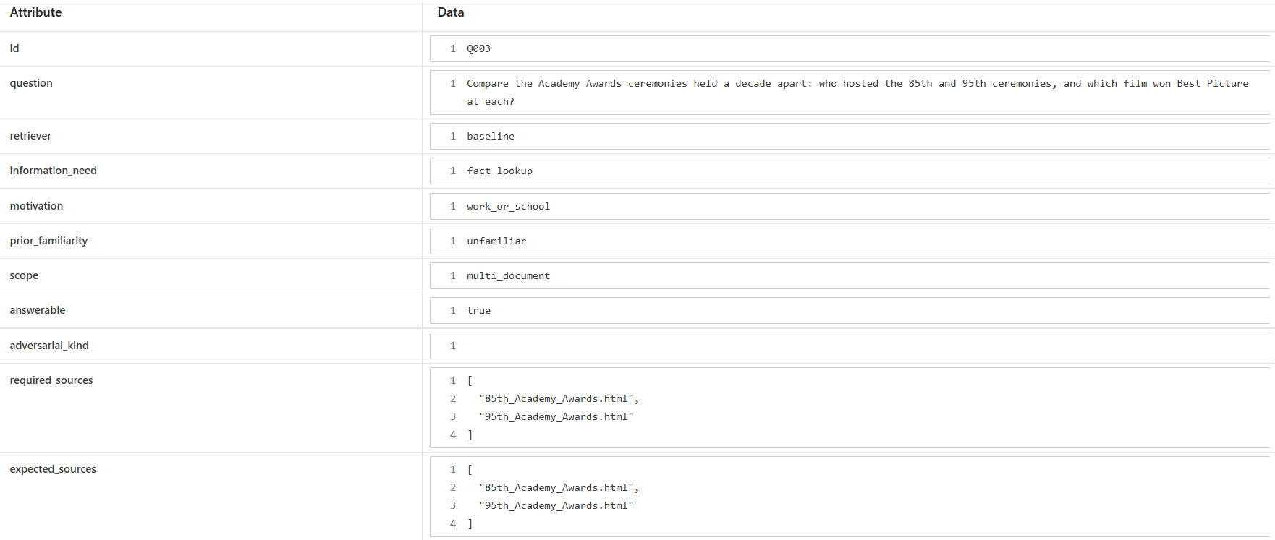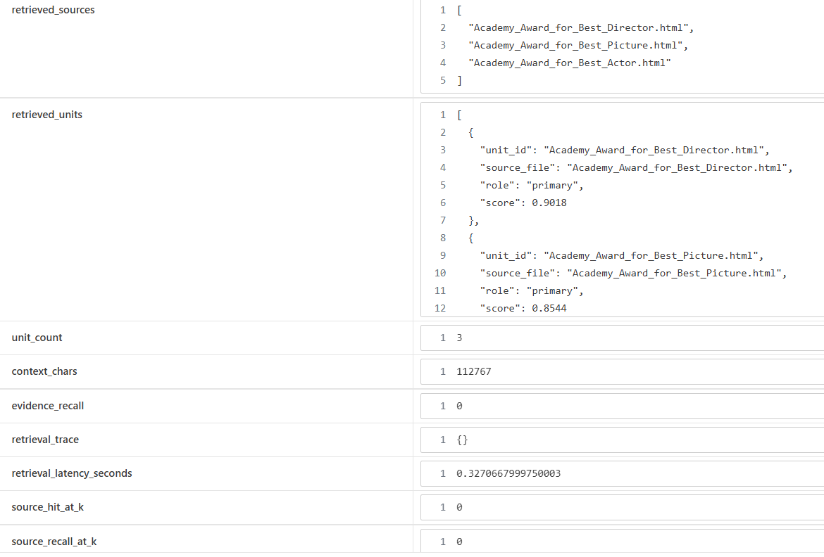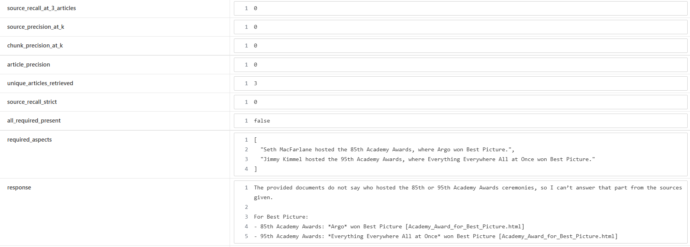
(3) G13 “What was the former name of the university where Barack Obama earned his law degree?”
Here the system was able to determine that Barack Obama earned his degree at Harvard University but was unable to determine that the institution’s former name was Harvard College. Source recall at k and aspect coverage were both 0.5.
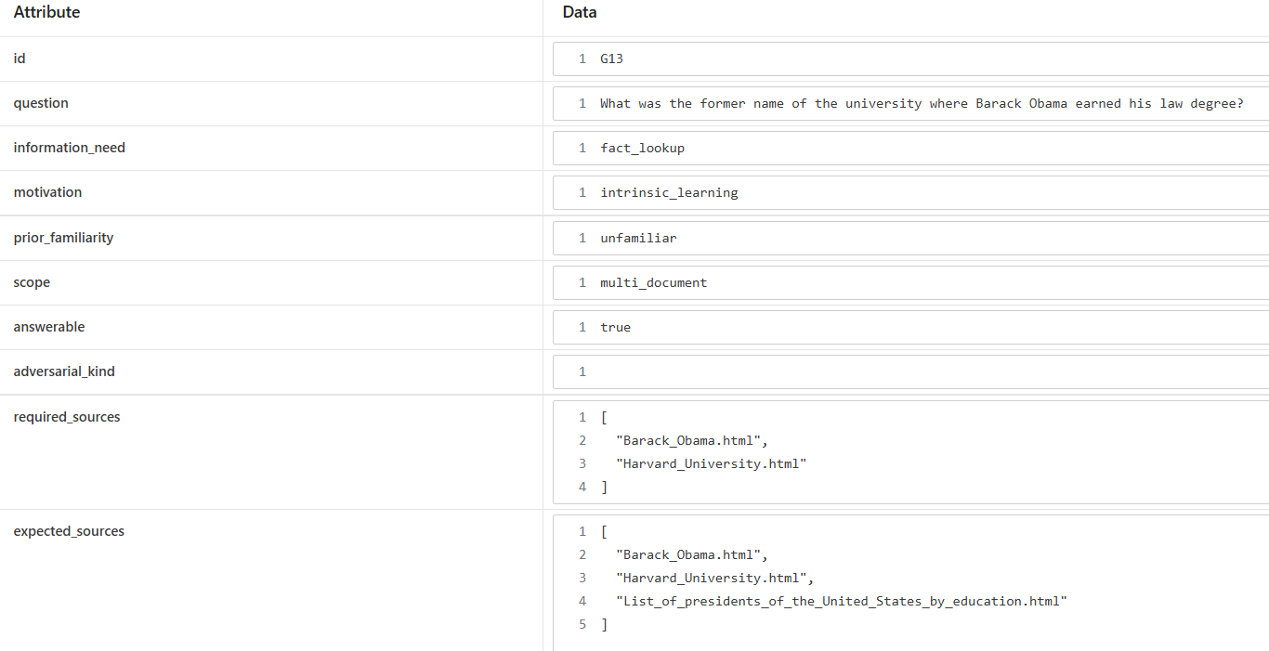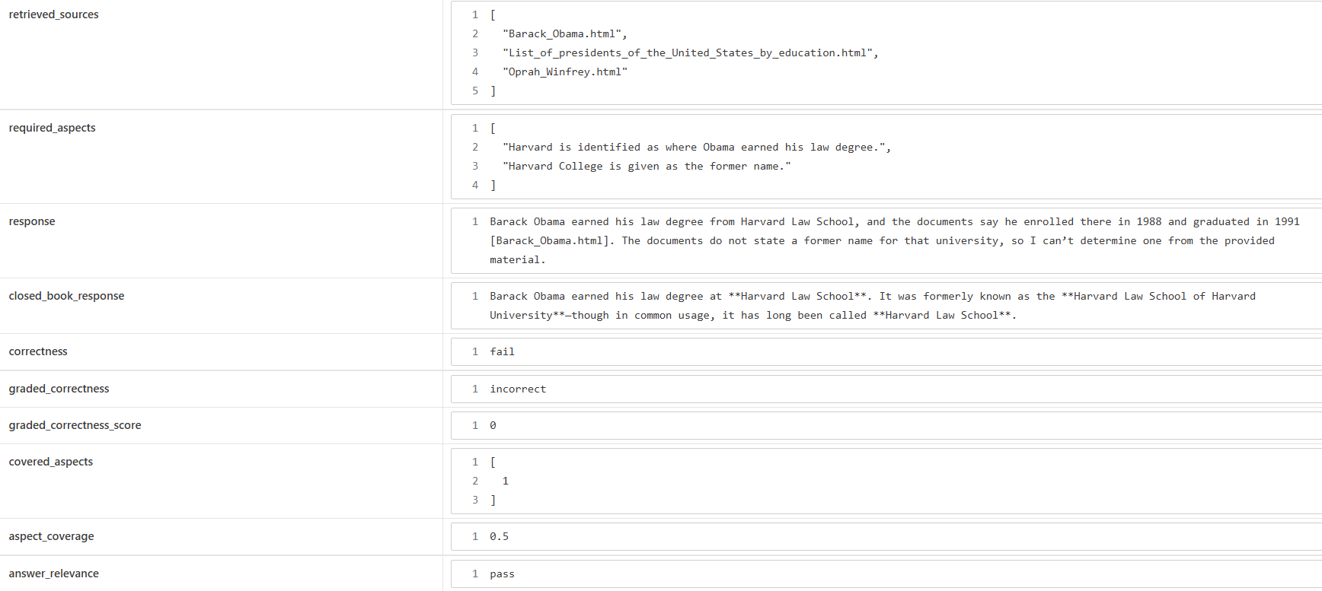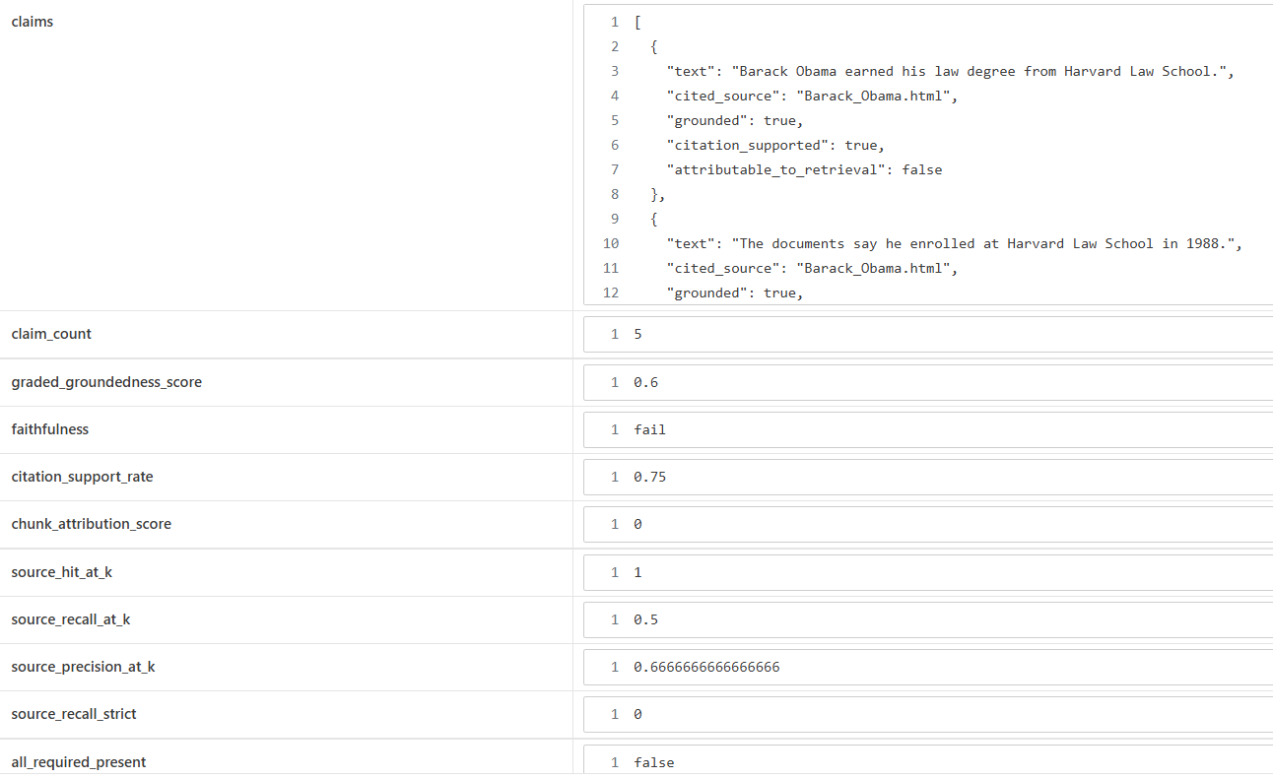

Step 2. Failure Analysis
Analyze why the retrieval failure occurs. Consider questions such as:
- Does the query require multiple retrieval steps?
- Is relevant information distributed across multiple documents, conversations, or entities?
- Is excessive irrelevant information being retrieved?
- Are important relationships within the data not represented effectively?
- Are there other factors contributing to the failure?
Likely cause(s) of the retrieval failure
- G16 “Was Charles II born before his mother’s reign began?”
In this case the retriever the keywords “III / born / mother / reign” matched multiple monarch pages but none of the pages needed. The page for Charles II is 149k long.
- Q003 “Compare the Academy Awards ceremonies held a decade apart: who hosted the 85th and 95th ceremonies, and which film won Best Picture at each?”
In this case the partial answer was enabled by retrieving the source “"Academy_Award_for_Best_Picture.html", but it was unable to answer who hosted the two award ceremonies, since it failed to retrieve the required documents "85th_Academy_Awards.html" and "95th_Academy_Awards.html". There are many documents in the corpus about the Academy Awards but with TOP_K=3 the chances of getting the exact documents needed to make the comparison is slim.
- G13 “What was the former name of the university where Barack Obama earned his law degree?”
In this case retrieval was partially successful, retrieving two of the three expected sources: "Barack_Obama.html" and "List_of_presidents_of_the_United_States_by_education.html", but because the query did not include “Harvard”, the retriever failed to retrieve “Harvard_University.html”, instead picking up “Oprah_Winfrey.html”, which contained several references to Barack Obama, whom Oprah endorsed in 2008 for President.

Why the current retrieval architecture struggles
The current architecture struggles when it is forced to search multiple, sometimes very long, documents with significant overlapping vocabulary for very specific details, but is configured to surface only 3 documents (TOP_K=3), or when the entity connecting the most important documents is not actually named in the query. In all these cases both a lexical and a semantic search ends up surfacing many potential candidate documents all competing for the top 3 slots. In the case of a query with an unnamed entity connecting two documents, it is happenstance whether an article about the unnamed entity itself will surface, because lexical and semantic searches are blind to the unnamed entity.

Step 3. Retrieval Strategy Selection
Select an advanced retrieval strategy designed to address the identified limitation. Examples may include:
- Query rewriting
- Query decomposition
- Retrieval fusion
- Multi-hop retrieval
- Relationship-aware retrieval
- Graph-based retrieval
- Another advanced retrieval approach
Selected retrieval strategy
Each of the three failures can be addressed using the following advanced retrieval strategies:
- Text splitting and chunking
- Query decomposition
- Graph based retrieval

Justification for the selected strategy
- Text splitting and chunking to create finer grained searchable units of text, retrieved using a higher TOP_K and CANDIDATE_POOL for hybrid search, so that the chunks most relevant to the query rise to the top
- Decomposing a composite or comparison multi-entity query into sub-queries to increase the likelihood that the detail required about each entity can be retrieved and then fused to provide the required context
- Creation of a graph that establishes common relationships between entities to enable the system to go beyond the first hop to find what it needs

Step 4. Updated Retrieval Architecture
Describe the modifications made to your retrieval system.
- Summarize the architectural changes.
- Explain how the updated approach differs from the baseline system.
- Include implementation evidence where appropriate.
Description of architectural changes
I made two major architecture changes to the Checkpoint 3.1 script:
(1) amended the pdf extraction with a new function (extract_wikipedia_text) to add to the basic text extraction per document (extract_wikipedia_text). The new function does text splitting and chunking using LangChain’s MarkdownHeaderTextSplitter (to capture headings) and RecursiveCharacterTextSplitter (for long text), and uses Beautiful Soup to extract some of the semantic properties such as Wikilinks, categories, and infoboxes, to generate graph data (nodes and edges) for later use in building a network graph.
(2) amended the script to be run with one of four different retrievers (baseline, chunks, decompose, graph) using the –retriever argument. The baseline retriever is just the same code as the 3.1 checkpoint. The other retrievers use process_wikipedia_with_nodes_and_edges. If the script is called with “chunks” then a chunk index and chunk vector store is created and used for retrieval, which adopts a parent-child retriever model configured by default to extract the chunk that got the hit, neighboring chunks, plus the leading chunk and associated info box for the Wikipedia article. If the script is called with “decompose” then it builds upon the “chunks” option and decomposes the query into sub-queries and fuses the results. If the script is called with “graph” then a network graph is created from the WikipediaGraphData nodes and edges and the graph is used to bring in chunks from category edges, wikilinks edges, or infobox edges to add to the context.

Implementation evidence (e.g., screenshots, code snippets, retrieval outputs, notebook excerpts)
- Here are some screenshots of the updated extraction script, which can be found at Capstone\Checkpoint 2.1\Extract_text_and_links_from_wikis.py. For documentation see Capstone\docs\Extract_text_and_links_from_wikis.md.
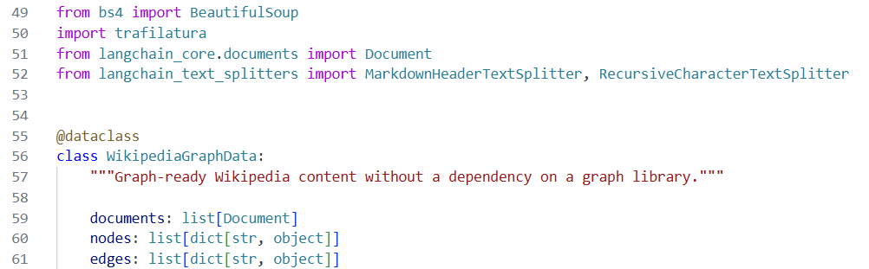
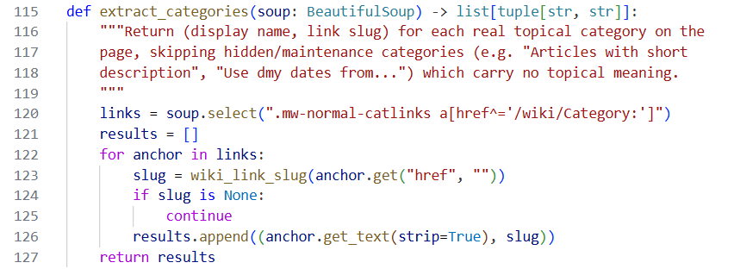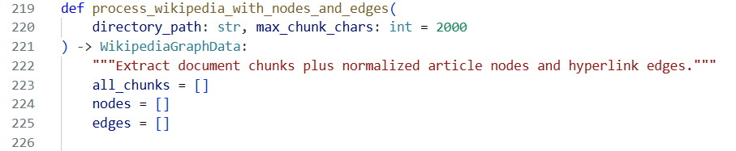
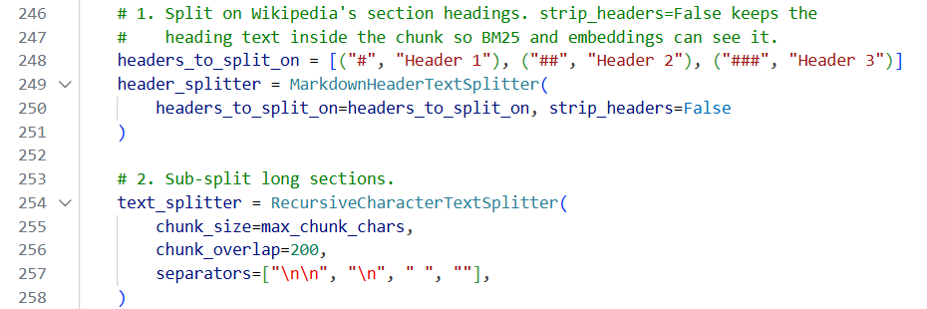
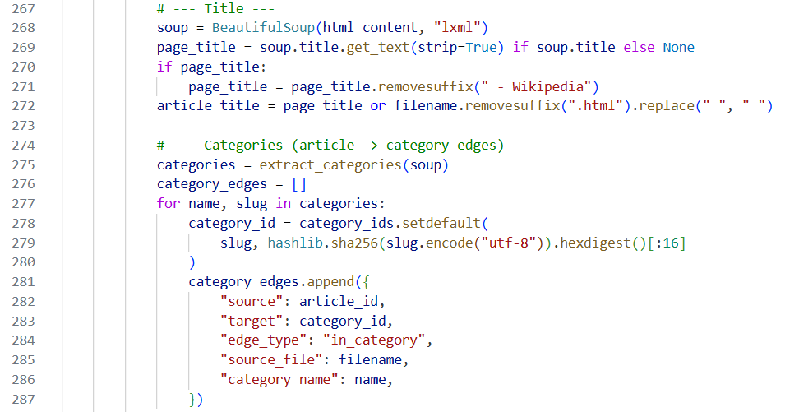
- Here is a flowchart of the main logic in the advanced retrieval system.
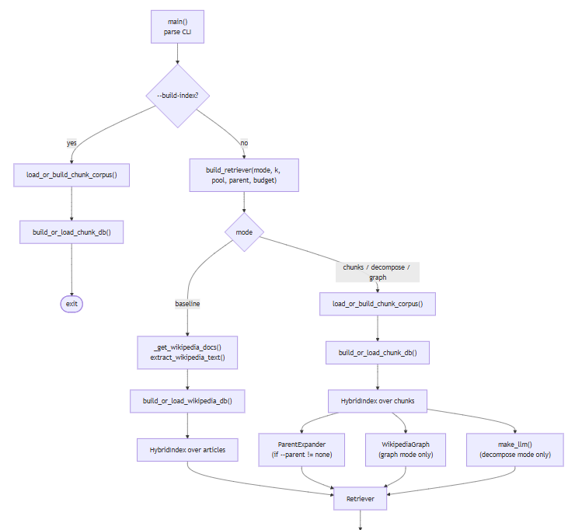
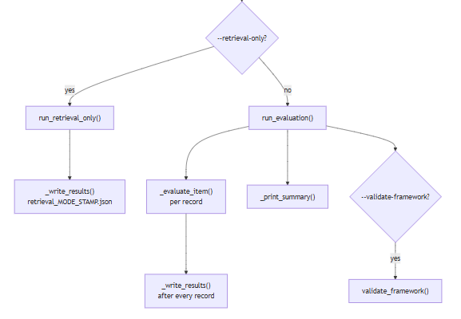
And here is a flowchart of the main query logic.
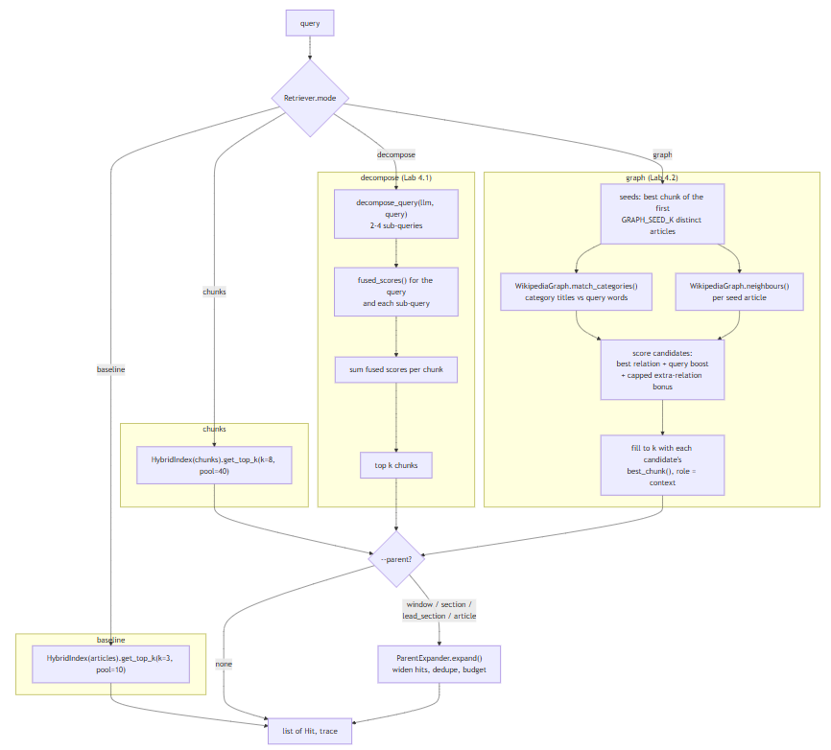

Step 5. Evaluation Results
Evaluate the updated system using the evaluation framework developed in previous modules.
- Present evaluation results.
- Compare performance against the baseline system.
- Include representative examples.

Evaluation Metric | Baseline | Chunks | Decompose | Graph
Binary correctness | 7/17 (41%) | 6/17 (35%) | 7/17 (41%) | 8/17 (47%)
Mean graded correctness | 0.47 | 0.43 | 0.56 | 0.66
Mean aspect coverage | 0.55 | 0.56 | 0.69 | 0.67
Faithfulness (all claims grounded) | 10/17 | 10/17 | 11/17 | 9/17
Mean graded groundedness | 0.79 | 0.87 | 0.85 | 0.86
Mean citation precision | 0.66 | 0.76 | 0.85 | 0.78
Mean quote fidelity | 0.67 | 1.00 | 0.92 | 0.79
Mean chunk attribution | 0.60 | 0.62 | 0.48 | 0.59
Strict source recall (all required articles) | 6% | 41% | 47% | 59%
Source recall@3 articles (matched count) | 24% | 39% | 55% | 39%
Mean unique articles in context | 3.0 | 5.1 | 4.2 | 8.0
Precision | 37% (@3 articles) | 48% chunk / 42% article | 55% / 49% | 26% / 26%
Mean evidence recall (golden quotes in context) | 36% | 50% | 51% | 50%
Mean context per query | 225k chars | 29k | 25k | 39k
Mean tokens per record | 232k | 33k | 29k | 44k
Cost (17 records) | $3.00 | $0.46 | $0.40 | $0.60
Mean / p95 latency (all runs paced at ≥3.1 s between calls) | 10.0 / 13.3 s | 10.9 / 14.5 s | 14.2 / 19.7 s | 10.1 / 14.5 s
Compared to the baseline, every advanced retriever fared much better in terms of recall, but only the graph retriever fared better at correctness, even though its precision dropped significantly, and the chunk retriever actually fared worse on correctness. The decompose retriever fared best in precision and evidence recall (citations). After chunking, costs dropped significantly for all three advanced retrievers.
Example 1: Query, retrieved information, and result
- G16 “Was Charles II born before his mother’s reign began?”
The following screenshots taken from Capstone\Checkpoint 4.1\evaluation_results\evaluation_chunks_20260921_164639.json show that with “chunks” this time recall flipped from 0 to 1 while precision went from 0.0 to 0.5. All the chunks required to answer the question were now there for the LLM, which still produced an incorrect answer with “chunks” (a separate issue), but a correct answer with “decompose” and “graph”. The main takeaway is that the system found the right chunks to answer the question.
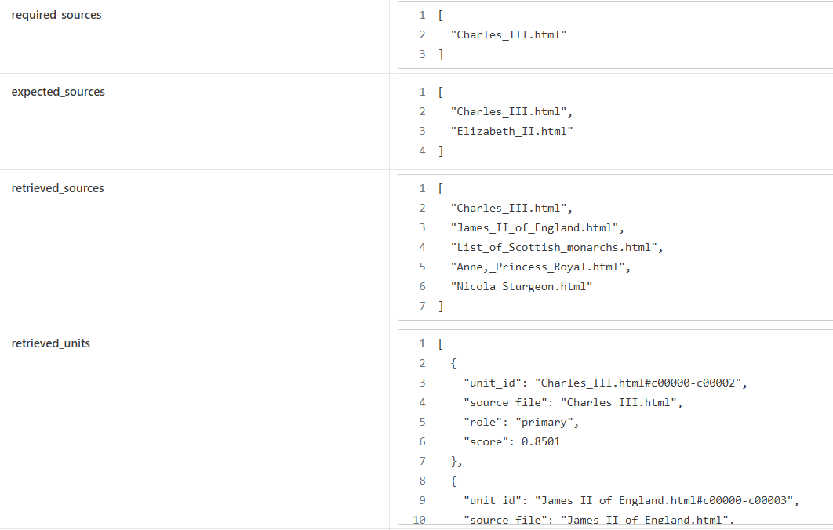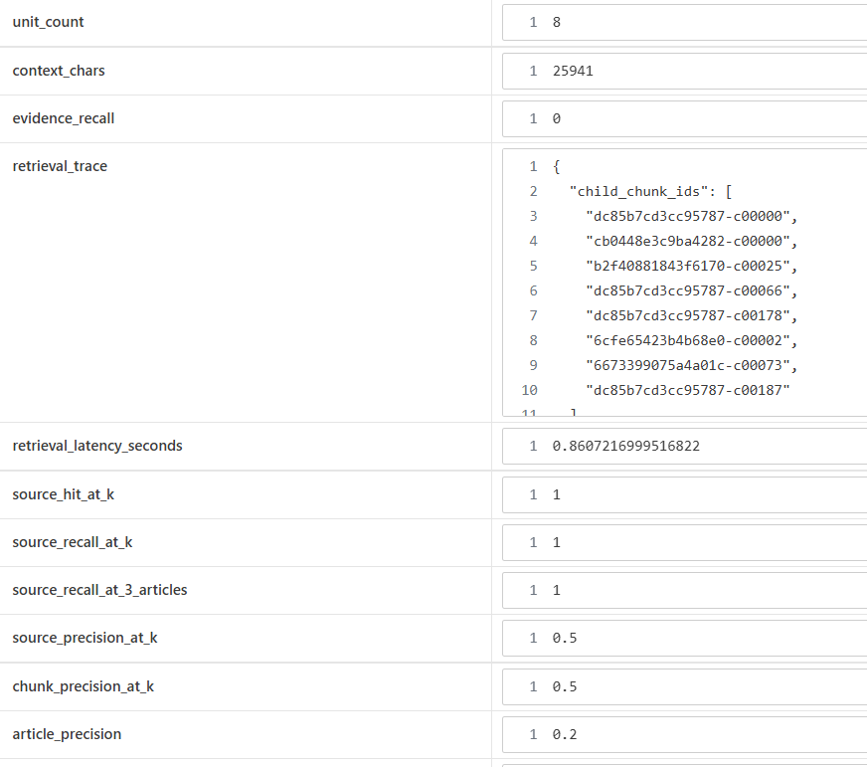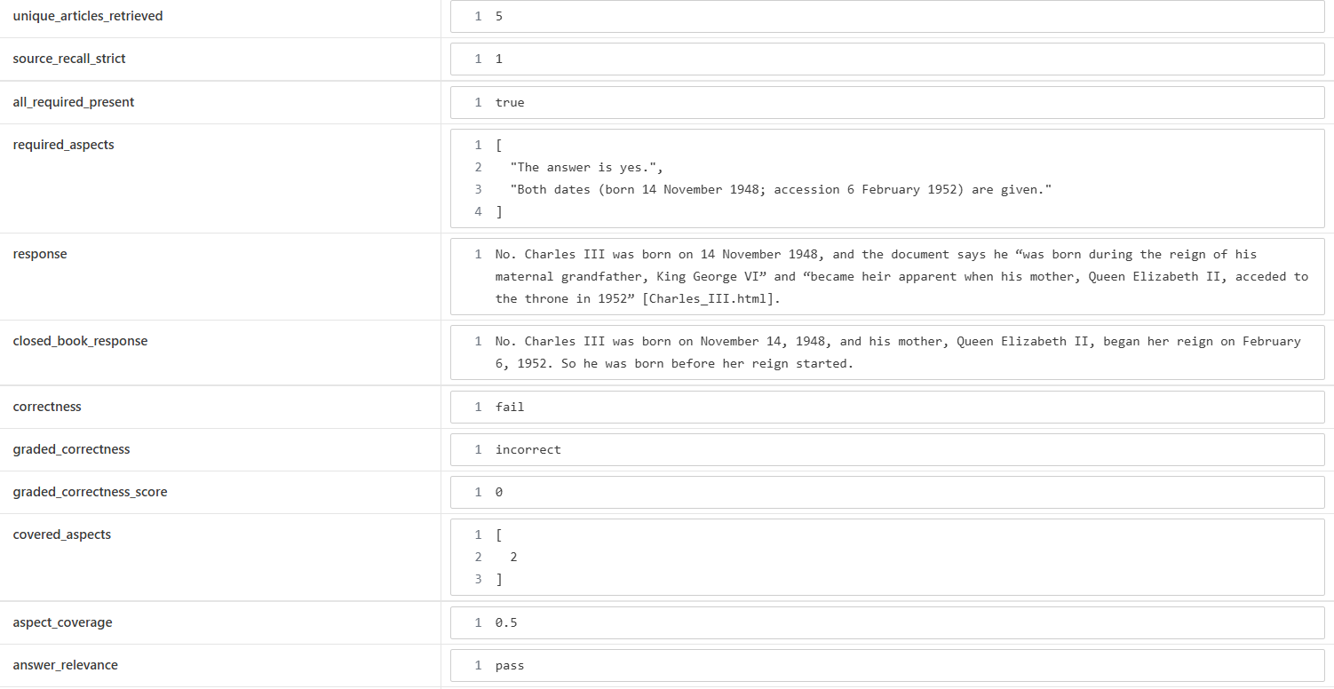

Example 2: Query, retrieved information, and result
- Q003 “Compare the Academy Awards ceremonies held a decade apart: who hosted the 85th and 95th ceremonies, and which film won Best Picture at each?”
In this instance, as reported in Capstone\Checkpoint 4.1\evaluation_results\evaluation_decompose_20260921_181908.json and shown below, with “decompose” the system was able to provide a complete and accurately cited answer, flipping recall from 0 to 1 and improving precision from 0 to 0.4. The key takeaway is that decomposition enabled the system to retrieve relevant chunks from the required documents related specifically to the 85th and 95th award ceremonies.
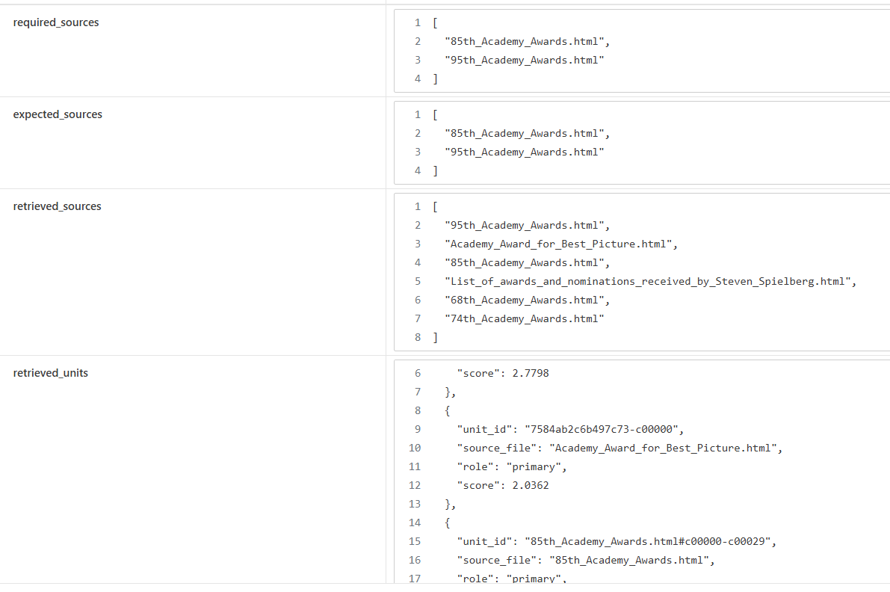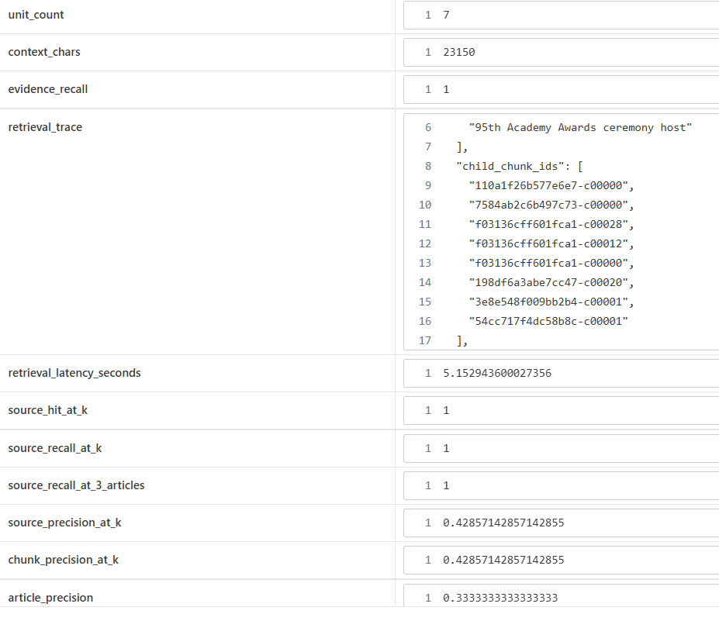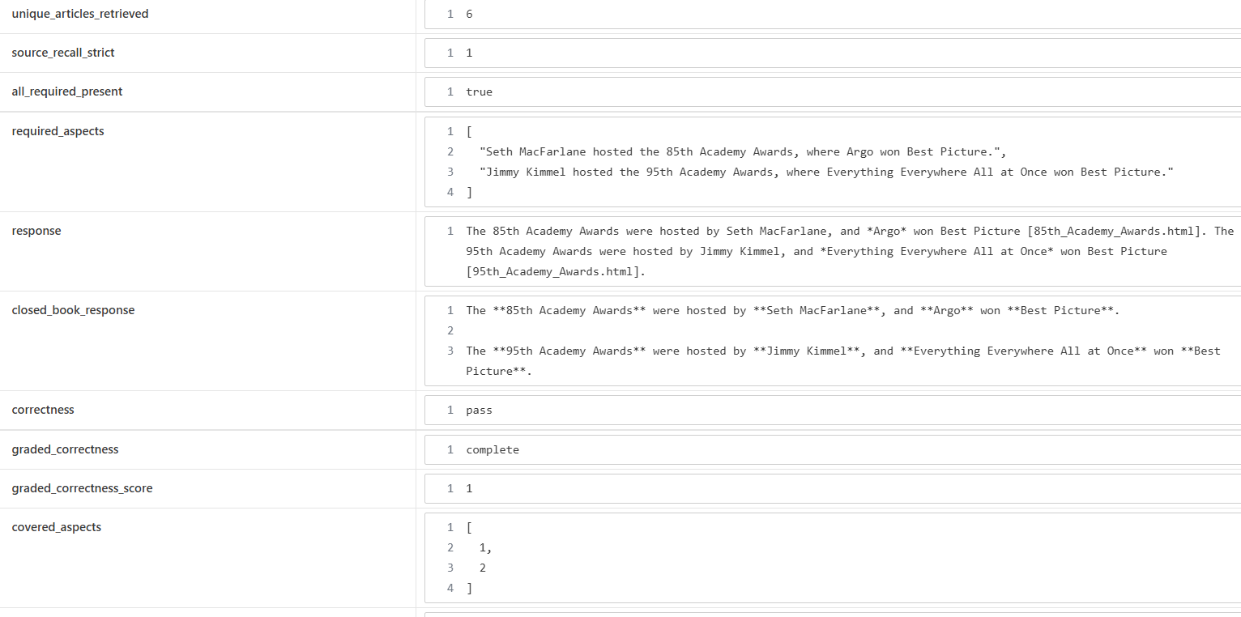

Example 3 (optional)
(3) G13 “What was the former name of the university where Barack Obama earned his law degree?”
Here the system with the “graph” retriever was both able to determine that Barack Obama earned his degree at Harvard University and was able to determine that the institution’s former name was Harvard College. As the screenshots below from Capstone\Checkpoint 4.1\evaluation_results\evaluation_graph_20260921_183400.json show, both source recall at k and aspect coverage went up from 0.5 to 1 and the answer flipped from fail to pass.
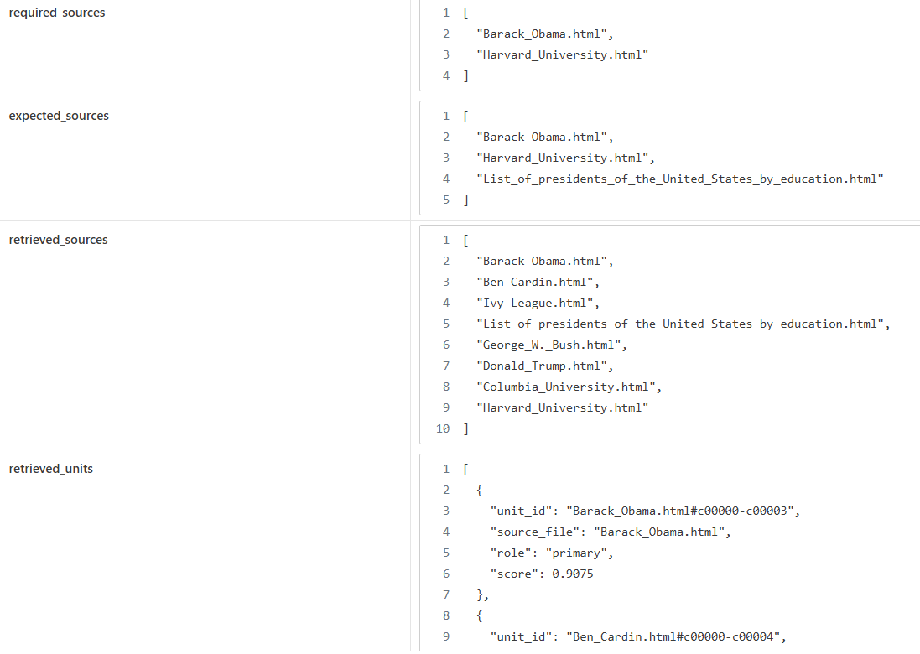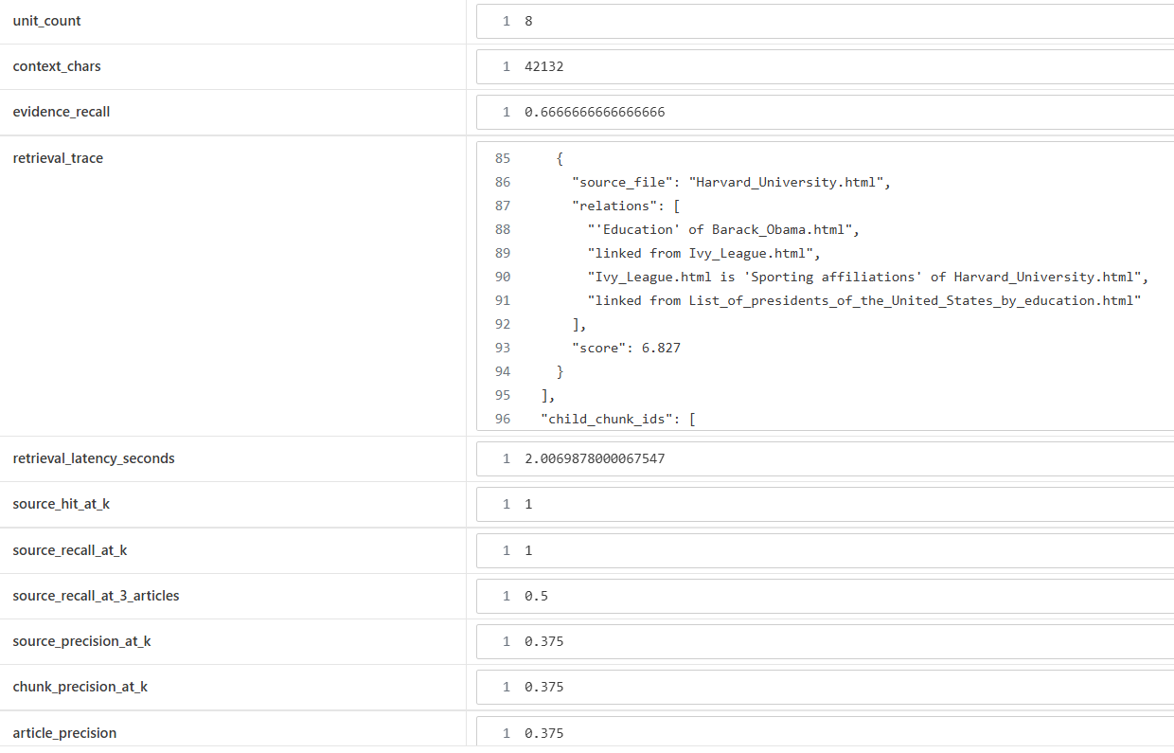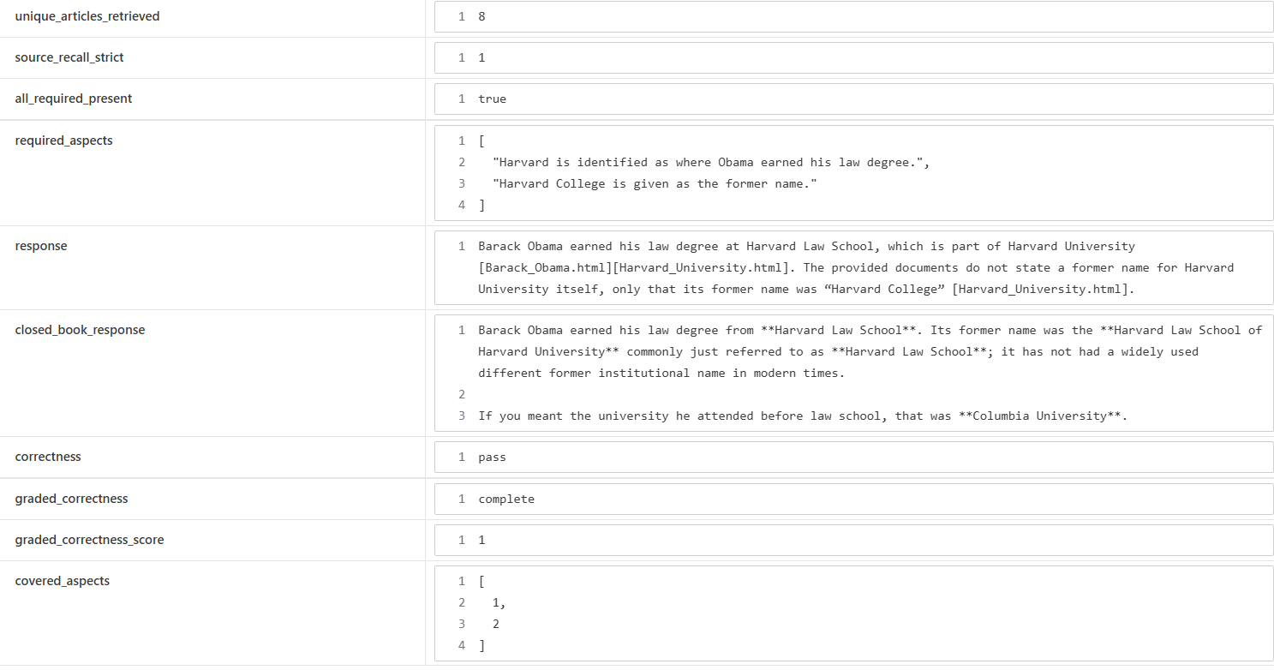

Step 6. Architectural Impact Analysis
Analyze the impact of the retrieval strategy.
- What improved?
- What remained challenging?
- Did the strategy address the original failure?
Improvements observed
All three advanced retrieval architectures showed significant improvements in recall (strict recall (all required articles) rose from 6% to 41%/47%/59%, and in the case of chunking and decomposition also with precision (which rose from 37% to 48% and 55% respectively). Correctness improved in the graph case from 7 to 8 but fell slightly with chunking alone from 7 to 6. The cost per record dropped from 18 cents to between 2 and 4 cents.

Remaining limitations or challenges
In this checkpoint I focused exclusively on retrieval. This still needs tuning, since each technique also had its losses: the chunker’s parent policy failed to retrieve the right chunk in the case that flipped from pass to fail, decomposition lost in two questions on single aspects, and precision dropped significantly for several question using the graph because of taking in too many irrelevant adjoining nodes (graph expansion needs to be constrained). Dynamically expanding parent scope might fixed parent policy problems.
But there are still several problems with the generation side, including the LLM accessing its own parametric memory during a decomposition run to answer sub-queries despite instructions to the contrary. Some of these generation problems could likely be fixed by tightening prompts and reducing temperature from 0.2 to 0.0.

Did the strategy address the original failure?
The strategy addressed some of the original failures but in a piecemeal fashion. On the whole chunking brought a significant improvement to retrieval across the board, as well as slashing cost.

Step 7. Reflection and Next Steps
Reflect on the effectiveness of the architectural redesign.
- What did you learn from implementing this strategy?
- What would you improve next?
- Are there additional retrieval failures that still need to be addressed?
Reflection on the architectural redesign
Checkpoint 3.1’s insights plus the lecture for module 4 led directly to a new test suite tailored to highlighting the gaps in the base retriever. This involved a deeper examination of the structure of Wikipedia articles and their semantic properties, the need to break the articles down into chunks to facilitate searches, and the introduction of new retrieval strategies to better handle multi-document and relational queries. Many of the required building blocks are now in place in the system.

Specific improvements or next steps
Each advanced retriever is adept at fixing specific problems related to a specific type of query but also introduces its own problems. To integrate these retrievers, what is needed is an orchestrator or router which analyzes the query and chooses the best retriever for the job, with a conditional edge which allows for further retrieval when required. And each retriever needs to be fine-tuned to handle regressions. Beyond that, several generation problems still need to be addressed with better prompting and tuning of hyperparameters. And interactive sessions will require a different test suite that accounts for the chat history and how this affects the LLM’s context.

End of Required Capstone Checkpoint 4.1
Return to the assignment page in the learning platform to upload and submit your completed capstone checkpoint and complete any remaining items in this module.

